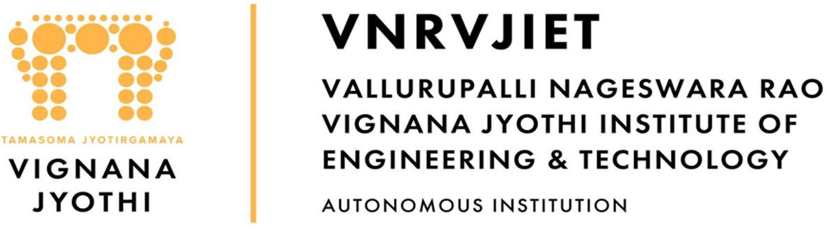

Day Report

I. Details of Scholarships:
Description | Total to be received | Received till Date | Received Date | To be received
Outstanding fees due  from the State Govt. | 2590189300 | 1354467700 | Till Date | 1235721600

Pending RTF Amount Year-wise Statement of 2014-15 to 2024-2025 A.Y as on 30.01.2026
S.No. | Academic Year | No. of Students | Total Tuition Fee in Rs. | Released No. of Students | Released Amount in Rs. | Pending No. of Students | Pending Amount in Rs.
1 | 2014-15 | 2578 | 111477600 | 2578 | 111535500 | 0 | -57900
2 | 2015-16 | 2971 | 145407000 | 2970 | 145497700 | 1 | -90700
3 | 2016-17 | 3060 | 164171600 | 3054 | 161864900 | 6 | 2306700
4 | 2017-18 | 3197 | 184686700 | 3196 | 180969300 | 1 | 3717400
5 | 2018-19 | 3372 | 206744500 | 3366 | 199886900 | 6 | 6857600
6 | 2019-20 | 3383 | 219041000 | 3366 | 216759600 | 17 | 2281400
7 | 2020-21 | 3197 | 249738500 | 2874 | 162593600 | 323 | 87144900
8 | 2021-22 | 3120 | 287671900 | 1025 | 97685200 | 2095 | 189986700
9 | 2022-23 | 3115 | 337126000 | 329 | 42755000 | 2786 | 294371000
10 | 2023-24 | 3308 | 363555500 | 720 | 34920000 | 2588 | 328635500
11 | 2024-25 | 3614 | 320569000 | 0 | 0 | 3614 | 320569000
 | Total | 34915 | 2590189300 | 23478 | 1354467700 | 11437 | 1235721600

Bank Credit Amount is 10995000/- Date 30.01.2026

II | Staff & Student Attendance Report : Attached.
III | MTP:
IV | HOD-M&MS:
V | HOD-AE:

VI | Particulars of Library Services and Transactions: | No.s
1 | Total No. of Books Issued or Check-out
2 | Total No. of Books Returned or Check-in
3 | Total No. of Students who visited the LIRC
4 | Previous day’s total No. of Users between 5.00 PM to 8.00 PM (16-02-2026)
5 | Staff Visited LIRC
6 | Visitors to Digital Library
7 | Show & Tell Visitors | --
8 | C.V.P.C Visitors | --
9 | Plagiarism check conducted through Turn-Tin Anti Plagiarism Software | - Staff Papers
Dr. B.Chennakesava Rao
Principal

